Animals of Georgia
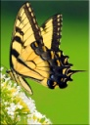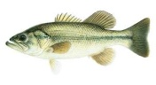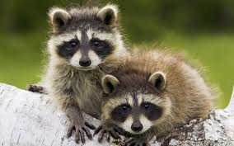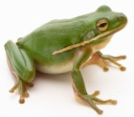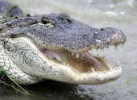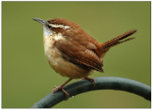

This project is due on February 20.
Materials
- Poster board
- Crayons, colored pencils, or markers
Directions
- Find out about one of each kind of animal—a mammal, a reptile, a bird, a fish, an amphibian, and an insect. They must all live in Georgia.
- Research their habitats and their adaptations. I will give you some time to do your research in the computer lab on Wednesdays.
- Divide the poster board into 6 sections. Use one section for each animal.
- Draw and color each animal in its habitat. You may also print pictures from the internet or cut out pictures from magazines, however you will earn bonus points if you draw and color the animals and habitats yourself.
- At the bottom of each section, describe the animal’s habitat and the animal’s adaptation(s) that allow(s) it to survive, grow, or reproduce. Please write your descriptions in complete sentences and as neatly as possible. Yes—if you want to, you may type the information instead. You will not need more than 2 or 3 sentences.
- You will give an oral presentation on the animals you researched.
- Note to parents: ways you can help—with research, editing, and pacing the work of the project. Please, please let this be your child’s project.
Reminders: Some habitats of Georgia include swamps, the ocean, the coast, marshes, the mountains, forests, and the piedmont. Some adaptations may include camouflage, long beaks, sticky tongues, long legs, etc.
Rubric
Picture of each animal | 4 pts each | /24
Descriptions of habitats | 4 pts each | /24
Descriptions of adaptation(s) | 4 pts each | /24
Neatness |  | /10
Oral Presentation |  | /18
Total |  | /100

Name _____________________________________________

Animals of Georgia
Rubric
Picture of each animal | 4 pts each | /24
Descriptions of habitats | 4 pts each | /24
Descriptions of adaptation(s) | 4 pts each | /24
Neatness |  | /10
Oral Presentation |  | /18
Total |  | /100

Name _____________________________________________

Animals of Georgia
Rubric
Picture of each animal | 4 pts each | /24
Descriptions of habitats | 4 pts each | /24
Descriptions of adaptation(s) | 4 pts each | /24
Neatness |  | /10
Oral Presentation |  | /18
Total |  | /100

